**FLIGHT RESERVATION SYSTEM USING ZOHO.COM**

STEP 1:

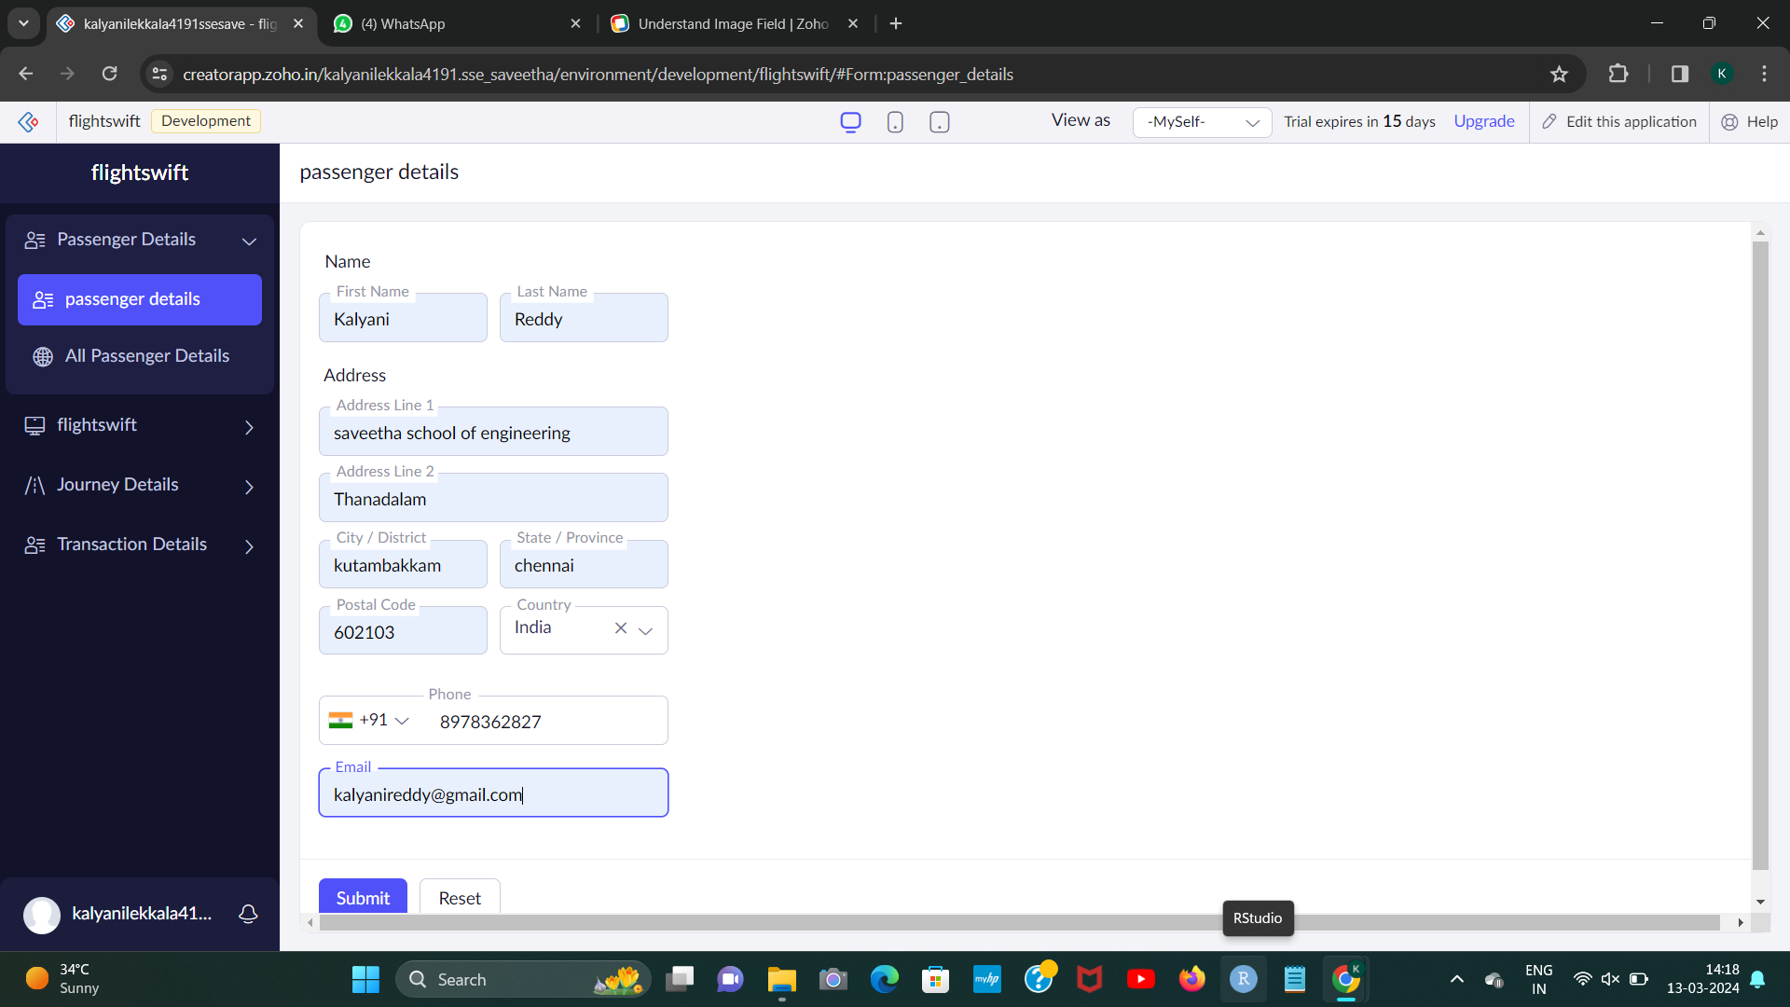

STEP 2:

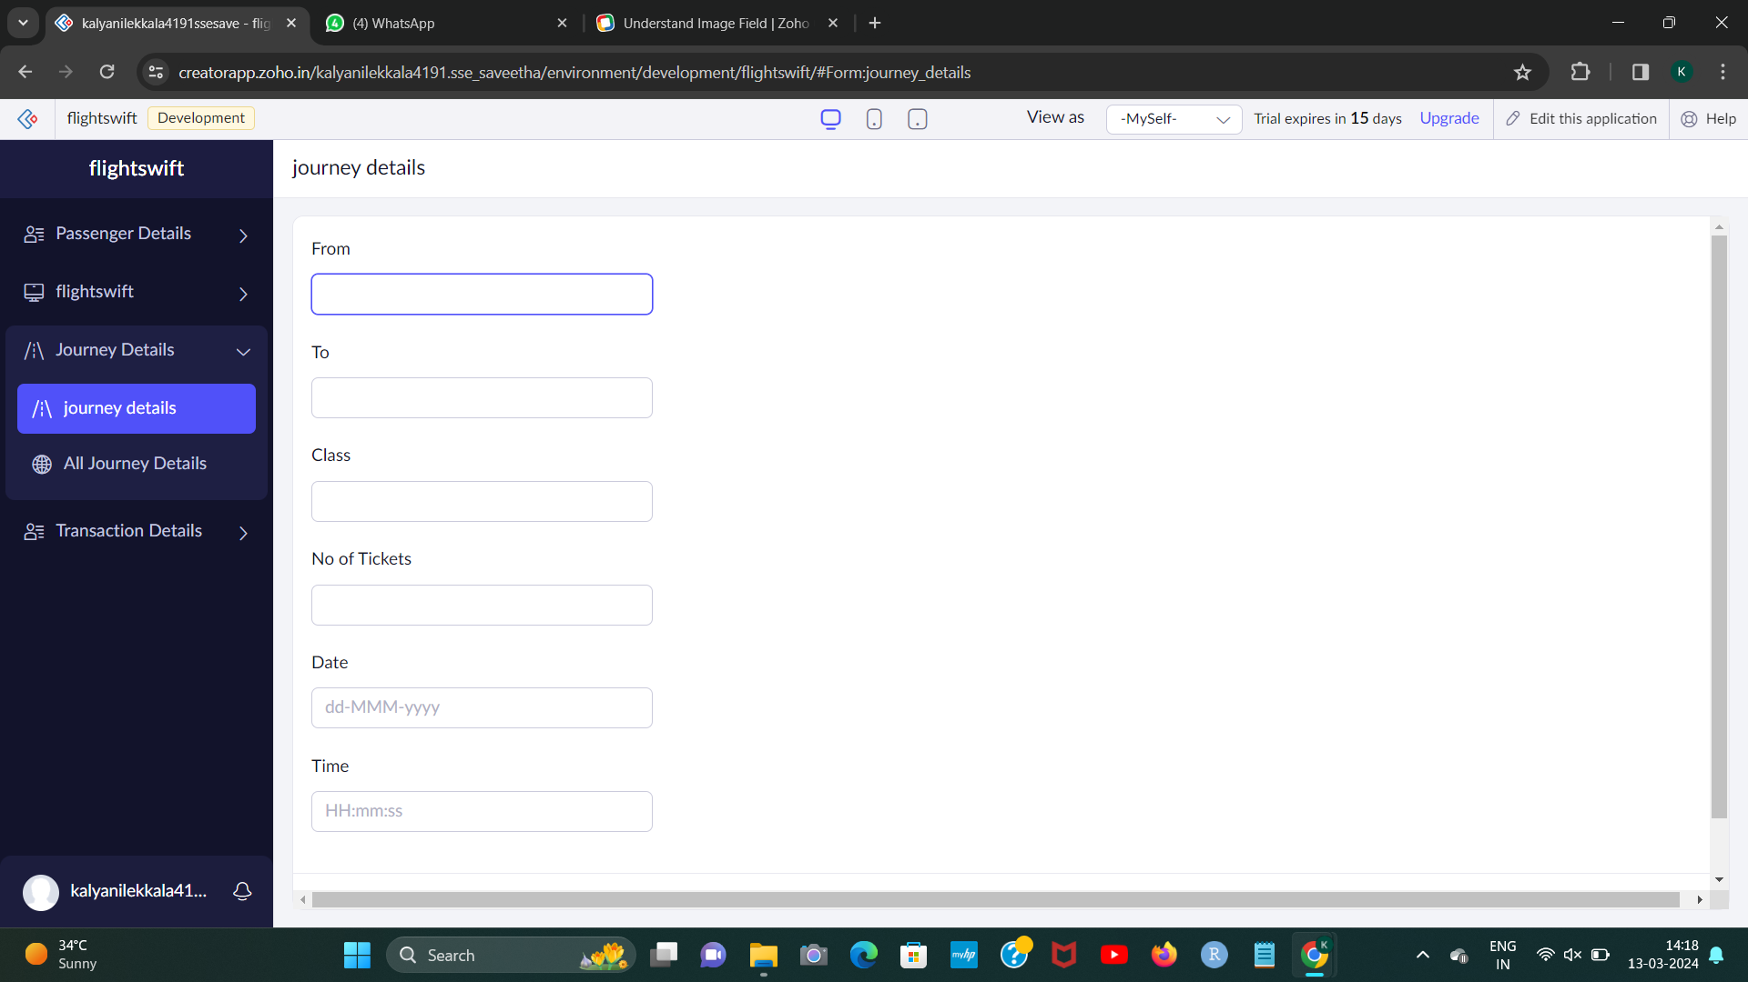

[1]

STEP 3:

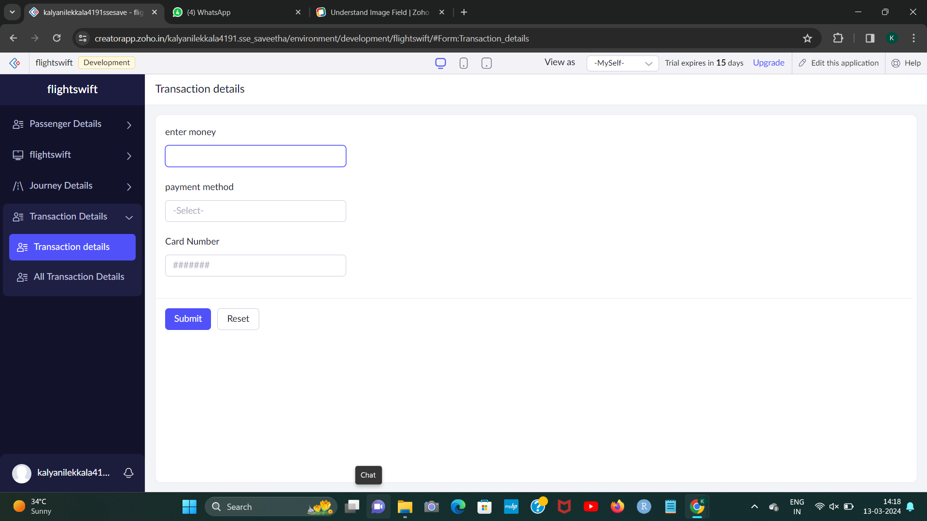[2]

1. L.KALYANI 192224191
2. L.KALYANI 192224191